Ultra-fast ARveo 8 advances possibilities for digital neurosurgery

Next-generation digital visualization microscope from Leica Microsystems

9. November 2021, Wetzlar, Germany – Leica Microsystems, a leading manufacturer of microscopes and scientific instruments, has released the ARveo 8, a digital visualization neurosurgery microscope with ultra-fast processing speeds. Through the use of advanced augmented reality (AR) visualization, ARveo 8 enables the entire neurosurgical team to benefit from an improved level of AR visualization by utilizing AR fluorescence imaging, IGS information, and endoscopic imaging. The ultra-fast processing capabilities of the ARveo 8 delivers visual information to users with a more natural, real-time feel to help them make informed and precise decisions during surgery. ARveo 8 helps increase efficiency in the OR, improves system accessibility for the entire team with its new graphical user interface, and provides the freedom to adopt more new technologies and AR applications as they become available.

“With ARveo 8 we keep unlocking the digital future to deliver the next era of surgical visualization and modularity by enabling the entire neurosurgical team to benefit from a new level of enhanced AR visualization, efficiency, and accessibility for most informed and precise clinical decisions. The next era of surgical visualization starts here, and the possibilities are endless,” says Markus Lusser, President of Leica Microsystems.

Together with EnhancePath, a concept for future upgradeability and system compatibility from Leica Microsytems, ARveo 8 provides a seamless way to evolve smoothly and confidently into digital neurosurgery as it advances.

ARveo 8 further enhances visualization for the user by adding layers of information from different systems directly onto the microscope image. Surgeons can add these to their view on-screen or through the oculars with additional visual information from pre-operative images, GLOW800 augmented reality fluorescence, image guided surgery systems, and endoscopic imaging feeds.

The new graphical user interface of the ARveo 8 and its recording unit are clearly structured with systems illustrations for easy setup and intraoperative functionality that can be tailored to the needs of each surgeon or surgery. This strips away interface complexities and allows more efficient workflows. With ARveo 8, neurosurgeons can choose to work through the oculars, heads-up displays, or both. Either way, the entire team can observe every move by following the procedure on the 31-inch microscope screen, the 55-inch 4K cart-mounted 3D monitor, or on the control panel screen.

The ARveo 8 digital visualization microscope for neurosurgery will be available from November 2021.

More information on the ARveo 8
Link to product page: https://www.leica-microsystems.com/products/surgical-microscopes/p/arveo-8/
News
https://www.leica-microsystems.com/company/news/news-details/article/ultra-fast-arveo-8-advances-possibilities-for-digital-neurosurgery/

Images and captions
Product image: The ARveo 8 digital visualization microscope for neurosurgery takes augmented reality visualization to the next level.
OR image: The entire team can follow the procedure on the 31-inch microscope screen, the 55-inch 4K cart-mounted 3D monitor, or on the control panel screen.
GLOW800 image: GLOW 800 augmented fluorescence enables surgeons to see anatomical details and blood flow in the same white light image.
Future image: ARveo 8 gives surgeons access to future technologies, unlocking the door to the future of digital neurosurgery.

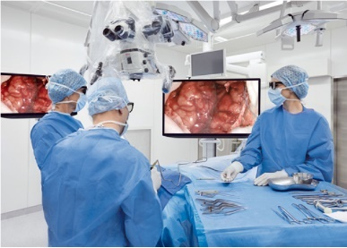
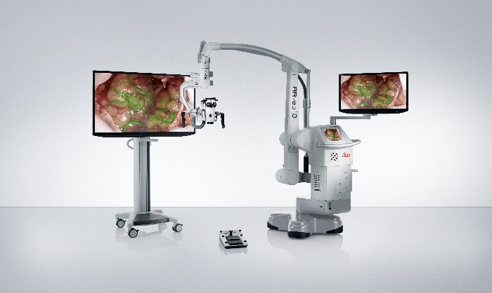

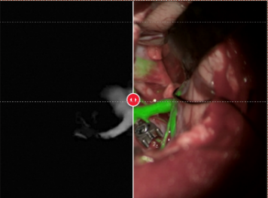

___________________________________________

About Leica Microsystems
Leica Microsystems develops and manufactures microscopes and scientific instruments for the analysis of microstructures and nanostructures. Ever since the company started as a family business in the nineteenth century, its instruments have been widely recognized for their optical precision and innovative technology. It is one of the market leaders in compound and stereo microscopy, digital microscopy, confocal laser scanning microscopy with related imaging systems, electron microscopy sample preparation, and surgical microscopes.

Leica Microsystems has seven major plants and product development sites around the world. The company is represented in over 100 countries, has sales and service organizations in 20 countries, and an international network of distribution partners. Its headquarters are located in Wetzlar, Germany.

